Oliver Collins-Cope

2102775@rutc.ac.uk

Learning Aim B & C

Develop a design for an Internet of Things system or device to solve a problem & Carry out the prototyping of an integrated Internet of Things system or device to solve a problem

Unit 19 Internet of Things

Assignment 2

Contents

Introduction 2

Problem definition statement 2

Purpose requirements 3

Diagrammatic illustrations and written annotations 3

Communication infrastructure 3

Feedback 7

Justifying alternative ideas and preferred solution 7

Improvements on design 7

Final design review 7

Creating the system 7

Optimisation 7

Evaluation 7

# Introduction

For this assignment I will be covering the benefits of a healthcare alarm that can aid in detecting when something happens to homeowners, such as someone breaking in. The advantages and disadvantages are vast for this, and some of the advantages include things like early detection for breaches of home, and peace of mind for household/family members themselves. The only disadvantages include the production costs and maintenance cost. This means that once the initial cost is covered and the IoT device is maintained, this device only benefits the homeowners.

# Problem definition statement

The problem in this scenario is the issue of having an alarm that can be used to detect whenever a door or someone has set off a motion alarm that can then alert the homeowner covertly, such as through a mobile notification. The intended audience of this would be the any homeowners looking to secure their property from malicious thieves.

The constraints of this project vary depending on the perspective you take, such as a lack of technical ability not knowing how to utilise these different aspects of the technology, like the motion sensor or camera. Another example of a constraint of this would be the cost to create and make all of these pieces of technology, or to purchase all of these components.

The benefits of using a motion detection system means that it will create a safer environment within the home for the homeowner, and it creates a self-sustaining alarm system that will constantly notify the homeowner if something happens within the home, like unauthorised access.

The nature of user interactivity here will be based in mobile applications and access to alerts/camera through this application. Due to this access, through the mobile application, the user will be able to gain access to their home and view it through the camera, while also being aware of any changes that might happen through the motion detection.

Some accessibility considerations of this application might be audible alerts that describe what can be seen on the camera, such as “a hooded figure moving across the room”, or audio alerts describing the time that the alert was made. Additionally, another accessibility feature that could help might be text-based options for the video feed, i.e., describing what is going on through the use of AI, or a microphone in the camera.

# Purpose requirements

The purpose of the IoT system is to address the alarm system. The system should be able of detecting any movement within a room using a camera connected to a Raspberry Pi or a similar microcomputer. Once movement is detected, the system must send an alert to a mobile device.

Several parts are needed to be able to complete this. Firstly, the system should provide a detection ability. This can be achieved by using cameras capable of differentiating between different types of movement, such as distinguishing a person from a pet, to prevent false alarms.

Next, the system should ensure real-time alert notifications. This means there is a need for consistent connectivity. Continuing, the system should be user-friendly and offer easy customisation of alarm settings, including setting up the app to receive alerts. The system should also provide an interface for system status monitoring and alarm management.

Lastly, the system should be designed considering scalability. As houses expand, the system should allow for an easy integration of additional cameras and motion sensors and be adaptable to new technologies and standards in the IoT ecosystem.

# Diagrammatic illustrations and written annotations

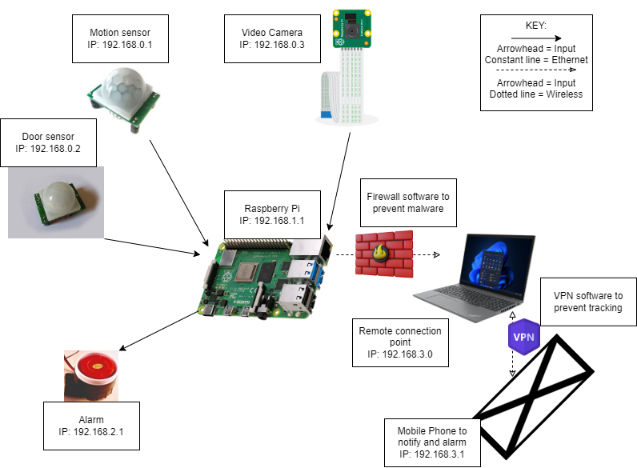

# Communication infrastructure

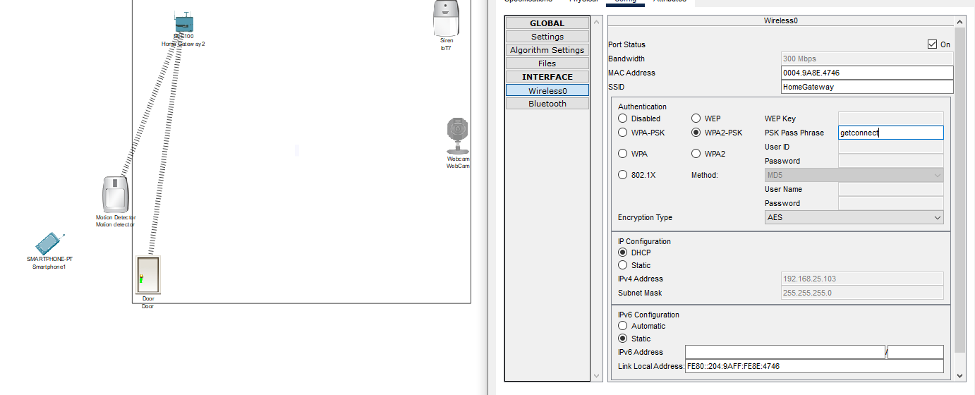

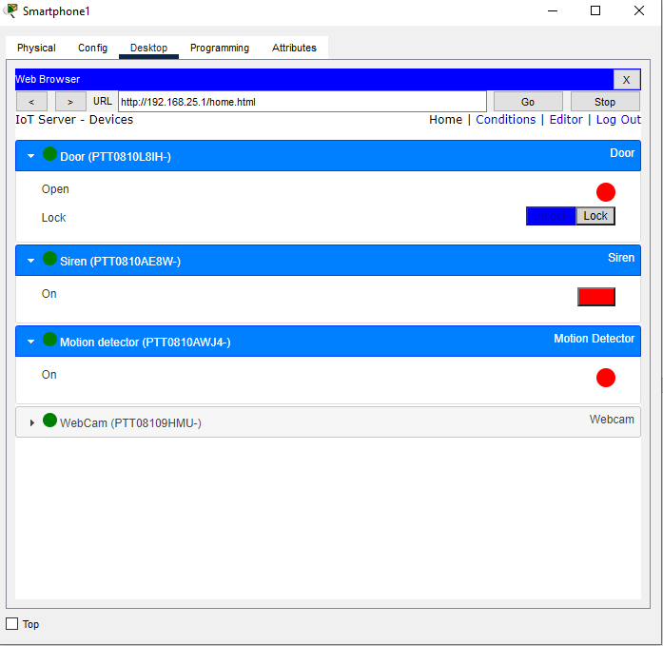

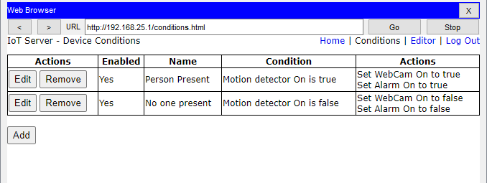

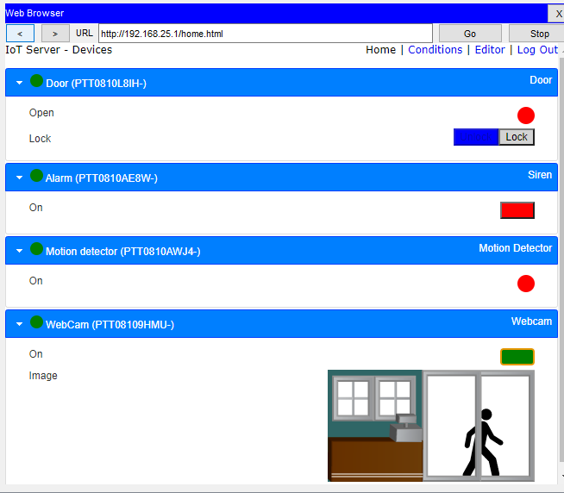

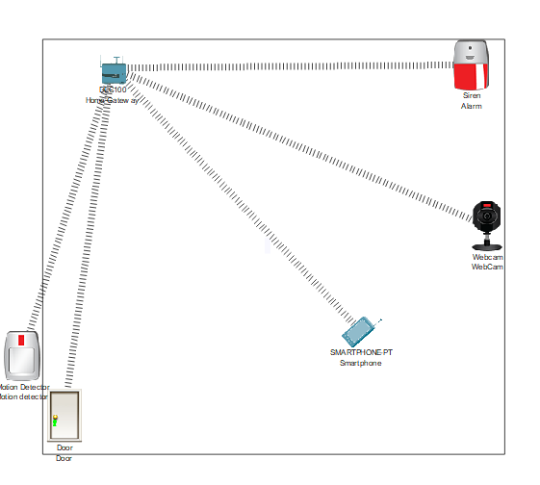

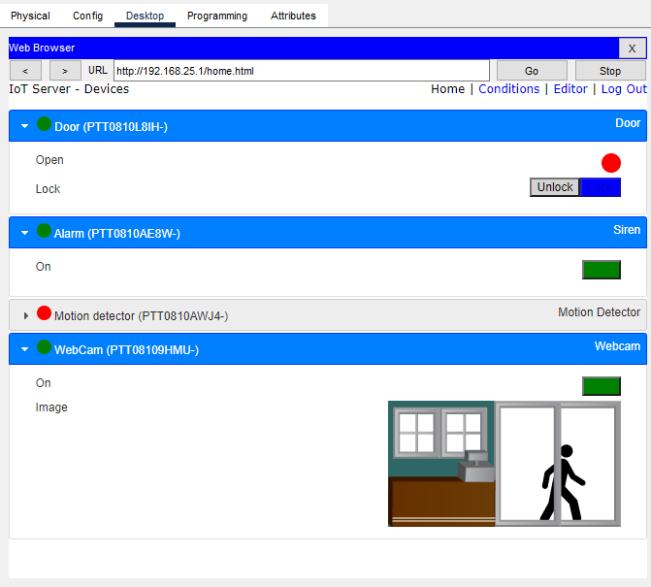

# Feedback

# Justifying alternative ideas and preferred solution

# Improvements on design

# Final design review

# Creating the system

# Optimisation

# Evaluation

S